Ermanno Olmi Award - 6th Edition
Bergamo, Lo Schermo Bianco (via Daste e Spalenga, 13)
Tuesday, December 3rd, 2024

Mamo by Jan Ziewiecki (Poland, 2024) wins the Ermanno Olmi Award,
an event aiming to promote short films by young directors.

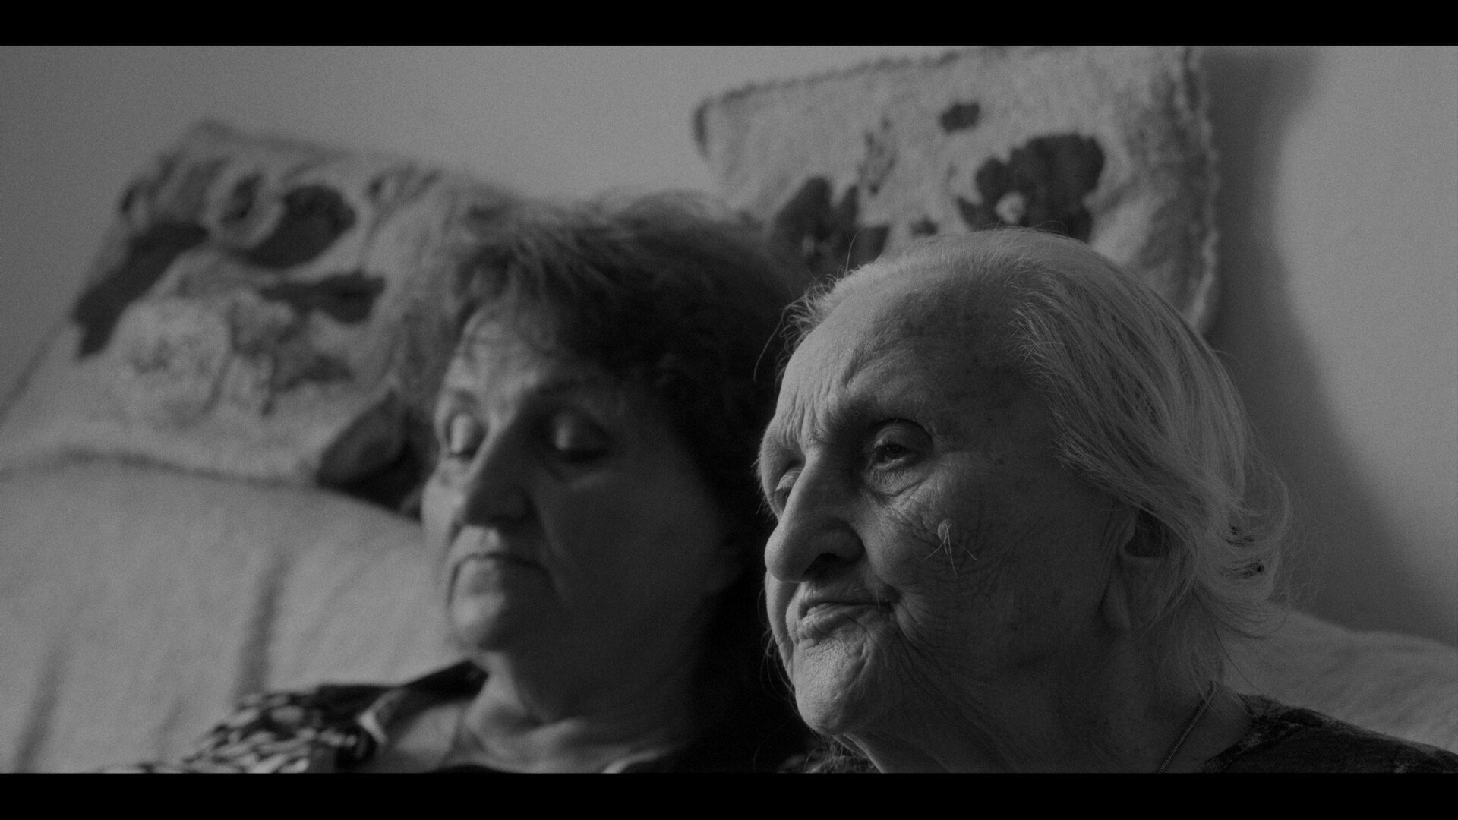
Mamo by Jan Ziewiecki

PRESS KIT
https://www.premioolmi.it/?lang=en#press-area

The short film Mamo by Jan Ziewiecki (Poland, 2024) wins the 6th Edition of the Ermanno Olmi Award, an event aiming to promote short films by young directors.
Second place goes to We should all be futurists by Angela Norelli (Italy, 2023), and third place to Provocadora by Èlia Lorente Estopañan (Spain, 2023).
The special mention for the most significant work concerning “The exercise of peace”, a theme that Ermanno Olmi explored in various aspects throughout his film production goes to VOCE by Andrea La Puca (Italy, 2024).
The first three classified films – among more than 100 entries from Spain, Estonia, Belgium, Switzerland, Germany, the UK, Poland, China, Iran and Malaysia, and a substantial Italian representative - received a cash prize of €1.200, €600 and €400, respectively, while the special mention received a cash prize worth €300 offered by FIC - Federazione Italiana Cineforum.

The jury - composed by Chiara Cremaschi (screenwriter and director), Rossana Galimi (PhD student), Massimo Lastrucci (film critic and journalist), Elisabetta Olmi (producer) e Stefano P. Testa (director) awarded Mamo: «The film combines a rigorous documentary approach with a delicate, respectful, and empathetic perspective. The mother-daughter relationship is portrayed with depth, spanning three generations united by care and sharing». We should all be futurists wins second place: «Using vintage material from silent cinema for a delightfully contemporary story. A humorous short film that showcases an impressive selection of elements: screenplay, editing, soundtrack, and voice acting». Provocadora takes home the third prize: «The film explores the transition from childhood to adulthood with remarkable cinematic awareness. The direction is surprisingly mature, skillfully portraying a complex range of emotions with great evocative power. Curiosity and turmoil, lightheartedness and unease, ambiguities hidden behind reassuring appearances».
The jury also awarded a special mention concerning “The exercise of peace” to VOCE with the following motivation: «For its ability to enact a collective response to gender-based violence. The short film stands out for the expressive intensity of its acting and the power of its choreographic construction, which together convey a strong message of resistance through body and voice».

The event featured a screening of the four finalist films and a tribute to Ermanno Olmi with a screening of I fidanzati (1963). The film print was provided by the Cineteca Nazionale CSC, courtesy of Titanus.

In the words of Councillor for Culture of the Municipality of Bergamo, Sergio Gandi: «The Ermanno Olmi Award is a legacy worthy of particular appreciation, which the current City Administration wholeheartedly embraces, as it combines cinema with the younger generations, commemorating the renowned Italian director with an annual event. Dedicating space and resources to recognize the creativity of directors under 30 is the best way to keep cultural production vibrant, relevant to contemporary themes, and appealing to young people. This initiative also serves more mature audiences, who, through the lens of short films, can view the younger generations with curiosity and a more attentive, welcoming disposition. The numerous entries from around the world confirm that this Award has become a true benchmark for today’s film production».

The Ermanno Olmi Award is promoted by the City of Bergamo, with the support of Bergamo Film Meeting Onlus in collaboration with FIC - Federazione Italiana Cineforum.

Ermanno Olmi Award - 6th Edition

1st PRIZE - €1.200
Mamo by Jan Ziewiecki (Poland, 2024)
A tender look at the relationship between women, whose roles has been reversed by time. A daughter takes care of her old mother, but their bond is tested by fading memory. Ordinary activities take on new meanings and the presence of the other person becomes a source of strength in the face of the inevitable.

2nd PRIZE - €600
We should all be futurists by Angela Norelli (Italy, 2023)
At the turn of the 1910s and 1920s, in an allusive correspondence, Rosa confides in her friend Giorgina, telling her a secret: the machine-man envisioned by Marinetti is not a near future for mankind, as futurists say. It is a present for womankind, and Giorgina can unwrap it now.

3rd PRIZE - €400
Provocadora by Èlia Lorente Estopañan (Spain, 2023)
What can't be remembered. The summer memories of Vera at her grandfather's home, will be interrupted by some situations that will make us question the reality of her actions, fears and attitudes. A mature point of view of a broken childhood, a discovery.

SPECIAL MENTION - €300
VOCE by Andrea La Puca (Itay, 2024)
VOICE is an impulse, the need to give voice to those who have not been able to use their own. Andrea La Puca and Azzurra Nappi, collecting through an anonymous form hundreds of complaints of experiences of violence, give life to a female monologue that encompasses all the voices that could never be heard.

In accord with the Minimum Environmental Criteria - parameters of environmental sustainability for cultural events - signed by the Municipality of Bergamo, the Prize takes part in the European Green Fest project: a commitment to both environment and culture, and a fitting tribute to Ermanno Olmi, who, through his works, was always a keen supporter of environmental preservation.

Ermanno Olmi Award
info@premioolmi.it / premioolmi.it / facebook.com/premioolmi
+39 348 1022828
Press Office
Ada Tullo
adatullo33@gmail.com / +39 349 2674900

